BUS-310I-S01 International Business

SPRING 2025

Table 1: Course Information
Course | BUS-310I-S01 International Business
Days, Time | TH 9:30 AM -10:45 AM | Room | Kamm Hall, 202 Lecture
Professor | Dr. Sergio Robles
Office | KAMM 207E | Office Phone | 440-826-3405
E-mail | srobles@bw.edu | Cell Phone | 330-990-8698 (call or text)
Office Hours | TR 11:00 AM– 12:30 PM and By Appointment
Prerequisites | N/A
TEXT | Fundamentals of international business / Sumati Varma.  International Business, Mason A Carpenter, University of Wisconsin at Madison  Sanjyot P Dunung, Atma Global---these two texts are FREE and on Canvas

Course Description

This course is designed to give students an opportunity to become familiar with the particularities of conducting business in an international environment, by giving them the theoretical and practical foundations necessary to study this discipline in greater detail.

Learning Objectives

Using the revised Bloom’s Taxonomy of learning (please refer to Appendix A for additional information), the cognitive-based learning objectives of this course are:

A. To facilitate the student's understanding of the nature, structure, and distinguishing characteristics of the industrial or business-to-business market.

B. To provide a framework for understanding or analyzing organizational buying behavior in all sectors of the business market (commercial enterprises, government, & institutions).

C. To enhance the student's ability in applying demand analysis and segmentation techniques in the business market.

D. To develop the student's ability for managing the firm's global efforts directed to the business market; specifically, the course should provide a framework for understanding business international strategy development and, thereby, provide the student with decision-making capabilities in the field.

Using the Assurance of Learning Goals for the college, the skills-based learning objectives of this course are:
- Improve critical thinking skills: the ability to explore issues, ideas, and events before accepting or formulating conclusions.
- Improve information literacy skills: the ability to identify the need for information, locate an evaluate information, and use information to draw a conclusion.
- Improve teamwork skills: the ability to work and lead team processes.
- Improve verbal communications skills: the ability to effectively and efficiently prepare and deliver knowledge verbally.
- Improve written communication skills: the ability to develop and professionally express ideas in writing.

The learning objectives will be met through three primary processes: (1) by reading required texts, reviewing online tutorials, and participating in class lectures/discussions in order to remember-understand-apply knowledge, (2) by completing individual assignments designed to critically analyze and evaluate international business practice, and (3) by completing team-based business to business research assignments designed to create ideas for improving international business practice.

Please refer to Appendix B: Frequently Asked Questions for additional information.

TOPICS COVERED
Key aspects of strategic international business are covered in this course and students will engage in several primary activities.

- This course will explore international business and will end on how to seize global opportunities.
- Students will cultivate knowledge about the key facets of the global business environment.
- Students will also gain knowledge about how an organization can exploit opportunities in that global environment.
- The class will also cover entrepreneurship in a flat world —why the entrepreneurial context is changing, provide lenses for identifying and capitalizing on entrepreneurial opportunities.
- Finally, we will see how key organizational activities can be managed for global effectiveness.

Learning Components

Using the revised Bloom’s Taxonomy of learning (please refer to Appendix A for additional information), the learning components are divided into two categories: (1) comprehension & application, (2) creation, analysis & evaluation.

Comprehension & Application
- Exams (Exam): Complete two exams. Exams are usually written essays. Exams are individual.
- In class activity/Discussion (D): Four times in the semester, we will have an in-class activity or a discussion. This activity may require you to watch a short video or read an article before class or during class. The prompts for this activity will be on Canvas. More details will be provided during the semester. These assignments will be individual.

Creation, Analysis & Evaluation
- Application Assignment (AA): International Business research assignments that will include written project deliverables and a short presentation. The two application assignments will be team assignments. Assignment information and rubrics will be provided.
- Peer Evaluations/Professionalism (PEP): During the semester, you will have to complete two peer evaluations for the other members of your team. This will be completed on Canvas. You will also have to evaluate the other team members presentations (other than your own team) for the two projects. Finally, you may have points taken away for any unprofessional or irresponsible behavior during the class.

Grade Determination

The total possible points for this course are 1000 points. Grades are calculated using a maximum of 1000 points. The following two tables provide the point allocation details and grade determination.

Table 2: Course Point Allocation
Learning Component | Count | Points Per | Total Points | Type
Comprehension and Application (50%)
Exams | 2 | EXAM1=150  EXAM2=300 | 450 | Individual
In Class Activity/Discussions | 6 | DISC1=25  DISC2=25  DISC3=25  DISC4=25  DISC5=25  DISC5=25 | 150 | Team
Creation, Analysis and Evaluation (50%)
Application Assignments | 2 | PRJCT1(T)=100  PRJCT2(T)=200 | 300 | Team
Peer Evaluations/Professionalism |  | GP EVAL=25  PEER EVAL=25  PROFESS =50 | 100 | Individual
TOTAL | * | * | 1000 | *

Table 3: Letter grade determination
Grade | Points | Grade | Points | Grade | Points | Grade | Points
A | 930 – 1000 | B | 830 – 869 | C | 730 – 769 | D | 630 – 669
A - | 900 – 929 | B - | 800 – 829 | C - | 700 – 729 | D - | 600 – 629
B + | 870 – 899 | C + | 770 – 799 | D + | 670 – 699 | F (Fail) | 000 – 599

Appendix A: Bloom’s Taxonomy

In 1956, Benjamin Bloom (with collaborators Max Englehart, Edward Furst, Walter Hill, and David Krathwohl) published a framework for categorizing educational goals: Taxonomy of Educational Objectives. Familiarly known as Bloom’s Taxonomy, this framework has been applied by generations of college instructors in their teaching. The framework consists of six major categories: Knowledge, Comprehension, Application, Analysis, Synthesis, and Evaluation. With the exception of Knowledge, each category is conceptualized as “skills and abilities” in which knowledge is the pre-condition for putting skills and abilities into practice.

In 2001, a group of cognitive psychologists, curriculum theorists and instructional researchers, and testing and assessment specialists published a revision of Bloom’s Taxonomy with the title A Taxonomy for Teaching, Learning, and Assessment. The authors of the revised taxonomy use “action words” to describe the cognitive processes by which thinkers encounter and work with knowledge.

This course uses the revised Bloom’s Taxonomy to develop student’s cognitive knowledge about consumer behavior. The framework is for students to be able to remember → understand → apply knowledge first and then use knowledge to create, evaluate, and analyze. A graphical representation of the revised Bloom’s Taxonomy is provided below.

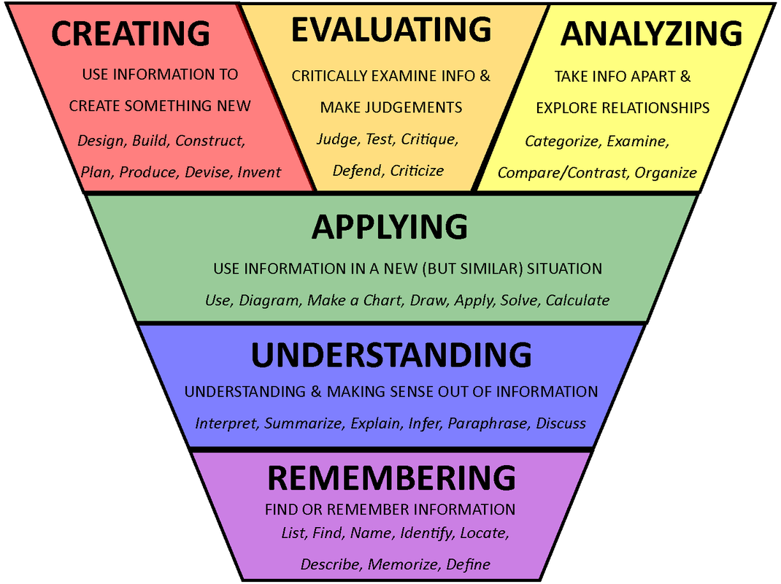

APPendix B: Frequently Asked Questions about THE Course

PERFORMANCE EXPECTATIONS: It is expected that students read all assigned chapters and examples and complete the assignments. Assignments will require you to meet specific deadlines and refer to the material learned throughout the course.

TECHNOLOGY: This course designed as a web-enhanced course. As such, the course content will be delivered both in class and on the web through the Canvas website. Guidelines for using the course Canvas will be provided. You should expect to use the Canvas website throughout the semester. In addition, you will need Microsoft Word, PowerPoint, and Excel.

STUDENT ROLE: My teaching philosophy treats students as co-owners of the course with decision-making responsibilities. As such, you should be prepared to voice your opinions about the course schedule, assignments, quizzes, and activities. When students voice opinions, we will make decisions together.

CLASS PREPARATION: You should prepare for each class session by (1) reading the class session materials and completing any associated tasks prior to the class meeting and (2) preparing to participate during class discussions by listening to and contributing to discussions.

TIME MANAGEMENT: Although the time spent varies widely among students, students should expect to spend approximately 6-9 hours per week on class activities outside of class. You should expect to spend more time during weeks in which you have individual and/or team assignments due.

MISSED DEADLINES / MAKE-UP POLICY: No credit will be given for late papers beyond the assigned due date and time. If you do not submit an assignment on time, you will lose all points associated with the assignment. Conflicts with work schedules do not constitute an emergency and must be planned for in advance.

COURSE POLICIES: All University Policies are in full force and effect in this class.

PLAGIARISM: In this course, plagiarism will refer to copying what somebody else has written or taking someone else’s idea and trying to pass it off as an original work. Cheating will refer to deceiving or misleading someone or any attempt to “break the rules” in an attempt to gain unfair advantage.

COURSE CHANGES: YES – I reserve the right to change, modify, add, or remove anything related to this course as the semester progresses. All changes in the schedule, course requirements, grading criteria, and/or learning components will be announced on the course website.

Point allocations may change depending upon the progress of the course. All changes will be announced.
In almost all cases, I adhere to the points required to earn the letter grade very closely in order to be fair and impartial to all students. However, I am willing to review well-constructed appeals for borderline students towards the end of each semester. All appeals must be submitted in writing by a time to be specified later in the semester. Feel free to discuss this with me as the course progresses.

